Email/Newsletter/Bulletin Language and Graphic

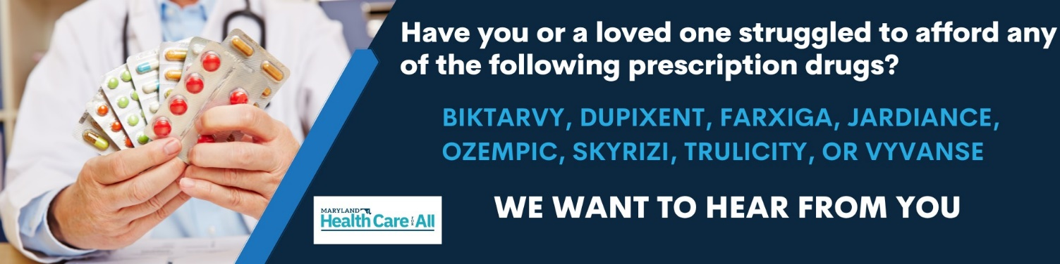
We are advocating with the Maryland Health Care for All! Coalition to make high-cost prescription drugs affordable for ALL Marylanders. Drugs don’t work if people cannot afford them. In order to overcome strong opposition from pharmaceutical corporations, we must raise up our voices.
If you have struggled to afford Biktarvy, Dupixent, Farxiga, Jardiance, Ozempic, Skyrizi, Trulicity, or Vyvanse, please share your story at www.healthcareforall.com/ShareMyStory or call (667) 212-2048.
An advocate from the Maryland Health Care for All! Coalition will then reach out to you to discuss how your story can make a difference in the fight to make high-cost drugs affordable for all Marylanders.
Learn more about this issue at www.healthcareforall.com. Thank you for your advocacy!

Social Media Post

Exciting news! Maryland’s Prescription Drug Affordability Board has chosen the first prescription drug products they will consider for review. If you or a loved one have struggled to afford any of these high-cost medications then share your story today at www.healthcareforall.com/ShareMyStory

Social Media Post and Story Graphics

