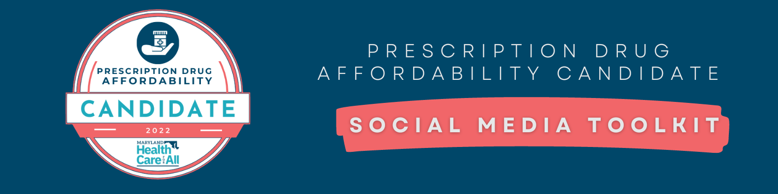

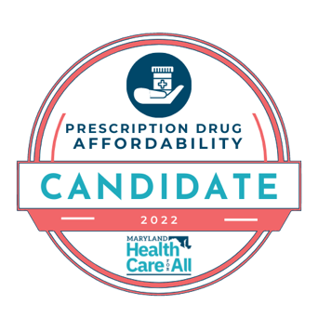
Thank you for your support for prescription drug affordability, together we can work to ensure Maryland’s Prescription Drug Affordability Board has the authority it needs to make medicines more affordable for all Marylanders. Our state needs #2022RxCandidates like you so that Maryland can continue to lead the way in health care!

Please feel free to use this logo on mailers, social media posts, e-blasts, or other campaign materials. To help us keep track of how you use it, please use the hashtag #2022RxCandidate in your online posts.

Graphics
Graphics included below can be used on Twitter, Facebook, or Instagram. Please contact catherine@healthcareforall.com if you are in need of the graphics in a different file format.

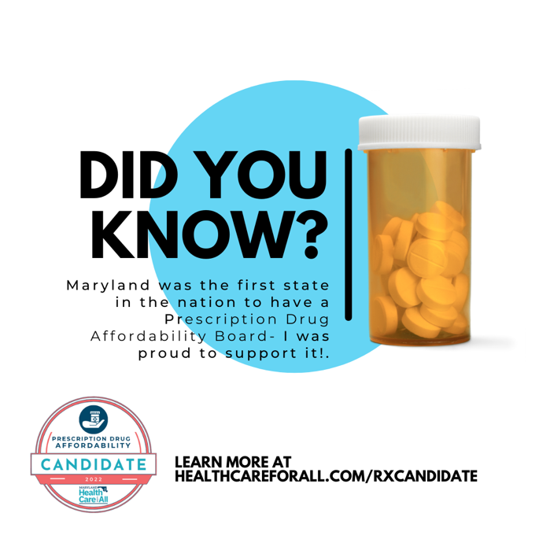

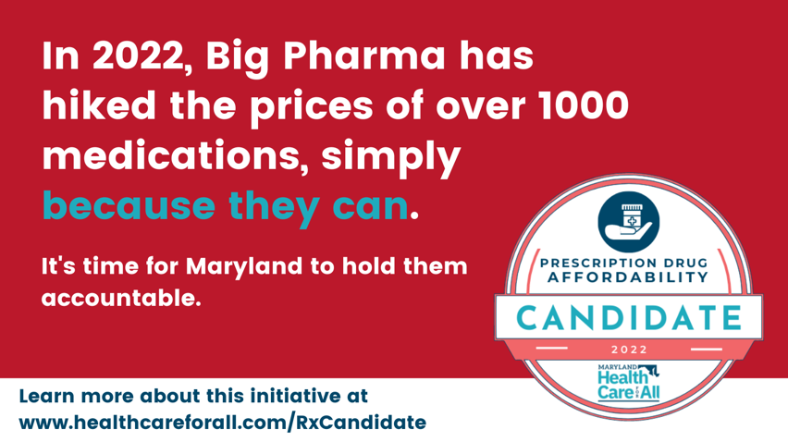

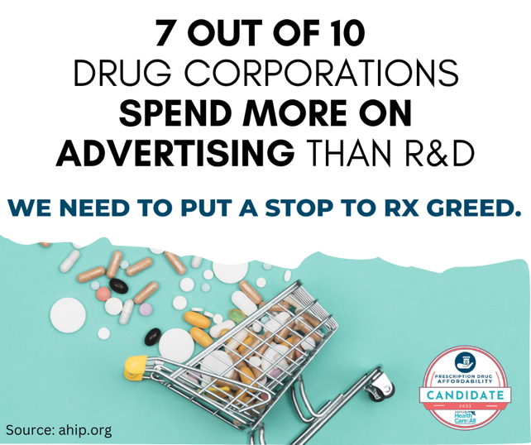
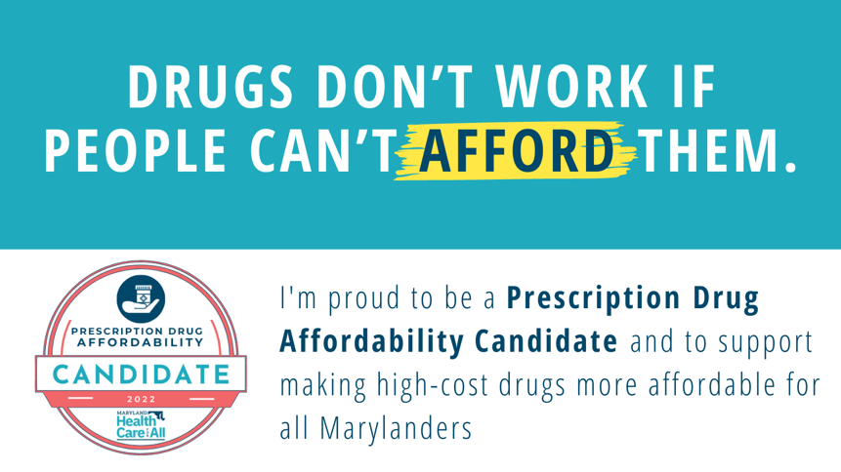
Facebook Post

Everyone deserves access to the care they need, and when the cost of prescription drugs skyrockets while corporations are making record profits, something needs to change. I’m proud to have supported the creation of the nation’s first Prescription Drug Affordability Board in 2019, and I am committed to continuing this work to ensure all Marylanders can afford the medicines they need. You can read about the progress we’ve made and what still needs to be done by visiting https://healthcareforall.com/RxCandidate

Tweets

Prescription drug affordability is a critical issue, and I’m proud to continue to stand with @HealthyMaryland and over 450 organizations across Md. who are choosing to do something about it. Learn more about the efforts at https://healthcareforall.com/RxCandidate #2022RxCandidate

When drug corporations put advertising and profits before patients, it hurts everyone. It’s time to stand up to Big Pharma. #AffordableDrugsNOW #2022RxCandidate

Care about health care and affordable prescription drugs? Learn why I’m standing up to support Maryland’s Prescription Drug Affordability Board to help our state’s residents: http://healthcareforall.com/RxCandidate #AffordableDrugsNOW #2022RxCandidate

No one should have to choose between affording medicine and other necessities, like rent and groceries. That’s why I stand with @HealthyMaryland to strengthen Md.’s Prescription Drug Affordability Board. Learn more at https://healthcareforall.com/RxCandidate #2022RxCandidate

We all pay the cost of high-cost drugs, whether it’s at the pharmacy counter, in our insurance premiums, or our taxes. It’s time Maryland stands up to Big Pharma. Learn more at https://healthcareforall.com/RxCandidate #2022RxCandidate

88% of recently polled Marylanders support the state having a Prescription Drug Affordability Board with the authority to make high-cost drugs more affordable for ALL Marylanders—I agree! Learn more about why I’m a #2022RxCandidate at https://healthcareforall.com/RxCandidate

For questions, please contact catherine@healthcareforall.com

