Prescription Drug Affordability Board Talking Points
Message: Maryland needs a Prescription Drug Affordability Board to help make high cost prescription drugs more affordable for Marylanders. Drugs don’t work if people can’t afford them.
- Patients are hurt by the high cost of prescription drugs—many Marylanders are forced to choose between their medication and other necessities, like rent and groceries.
Example: A woman with cancer was forced to choose between her treatment and electricity costs. As a result, she sat in the dark for six months in order to afford the medication she needed to survive.
Example: Every day, individuals who depend on insulin ration this critical medication due to cost. Despite having been on the market for nearly 100 years, costs have skyrocketed with little to no change in the product.
- Insurance premiums are driven up by prescription drug costs.
Example: CareFirst BlueCross BlueShield has reported that drug costs was the single largest contributor to overall spending in 2017, accounting for approximately 33% of total spending. (As reported by Chet Burrell, former CEO.) Even when the out-of-pocket costs for a patient are relatively manageable, the high cost of prescription drugs can be burdensome to the health care system.
- State/County budgets are impacted by the high cost of prescription drugs.
Example: Communities across Maryland struggle to afford naloxone, a lifesaving antidote to overdose. In recent years, some manufacturers have raised their prices over 500% during the height of the opioid crisis, leaving some first responders and health departments without adequate supply.
- Taxpayers are burdened by this issue. In addition to paying for our own drug coverage, our state taxes support the growing cost of drug coverage for Medicaid; prisons; and state, local, and university employees, retirees, and dependents. Approximately 31% of the state’s population falls into this category

- The United States spends significantly more on prescription drugs than other high-income countries. Without a rate-setting mechanism in place, pharmaceutical manufacturers charge whatever they deem the market can bear. As a result, Americans have the highest spending per capita on prescription drugs amongst high-income countries.
- Drug corporations spend more on advertising than they do on research and development. Despite claiming that one of the main reasons drug costs are so high is an investment in research, large drug manufacturers spend far more on advertising than they do on R&D. Notably, direct-to-consumer advertising has increased substantially in recent years. In 1997 there were 79,000 DTC advertisements. In 2016 that number had ballooned to 4.6 million DTC ads.

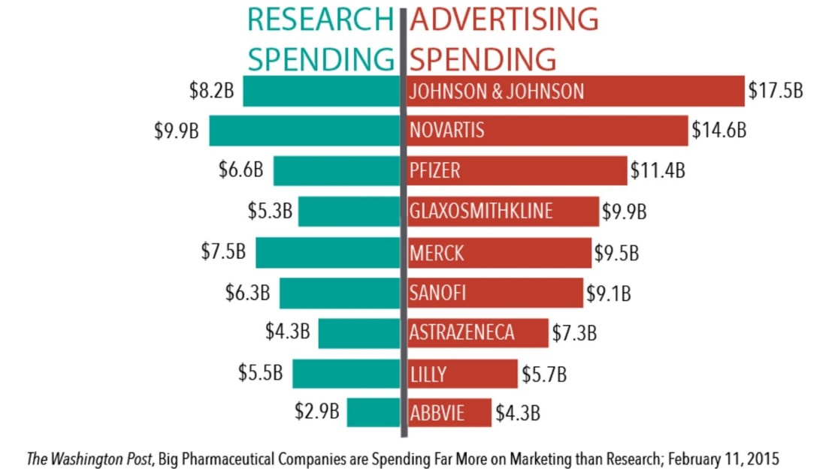

About the Prescription Drug Affordability Board
What it is: an independent body with the authority to evaluate high cost prescription drugs and set reasonable rates for Marylanders to pay.
What it does: The Board will review prescription drugs with costs that impact Marylanders, including high-cost, brand name medications. The Board will consider a broad range of economic factors when setting appropriate payment rates for reviewed drugs, allowing pharmaceutical manufacturers the opportunity to justify existing drug costs. Once a fair payment rate is determined, the Board sets an upper payment limit that applies to the entire supply chain.
Other notes: when talking about the Prescription Drug Affordability board, please use the terms “cost,” “rates,” or “upper payment limits” rather than the word “price.”

For additional information or questions, please contact Vinny DeMarco at 410-591-9162 or demarco@mdinitative.org

