Help spread the word about prescription drug affordability in Maryland!

Thank you for joining the Prescription Drug Affordability Coalition! Together, we can help Marylanders afford the medicines they need. Below we’ve provided some sample tweets and a Facebook post about this campaign which we would love to disseminate widely. We appreciate your help!

Tweets

It’s clear that drugs don’t work if people can’t afford them. That’s why [organization] has joined the Prescription Drug Affordability Coalition to create a Prescription Drug Affordability Board #AffordableDrugsNOW http://healthcareforall.com/rxresolution

Prescription drug affordability is a critical issue, and we’re proud to stand with @HealthyMaryland and over 250 organizations around the state as we work to lower the costs of prescription drugs. #AffordableDrugsNOW http://healthcareforall.com/rxresolution

One of the biggest issues facing Marylanders is #AffordableDrugs. No one should have to.choose between the medicine they need and other necessities. Join the hundreds or organizations working on this issue. #AffordableDrugsNOW . http://healthcareforall.com/rxresolution

Care about health care and affordable prescription drugs? Learn how to join Maryland’s Prescription Drug Affordability Coalition. http://healthcareforall.com/rxresolution

When drug corporations put advertising and profits before patients, it hurts everyone. It’s time we do something about this very serious problem. #AffordableDrugsNOW http://healthcareforall.com/rxresolution

Why do Americans pay so much more for prescription drugs than almost every other industrialized country? Learn more about #AffordableDrugs and how we can make a difference in our state: http://healthcareforall.com/rxresolution

Did you know? Drug costs are skyrocketing, while many drug corporations spend billions more on advertising than they do on research. That’s just wrong. Check out the Marylander organizations standing up to do something about this crisis: http://healthcareforall.com/rxresolution

Twitter Banner

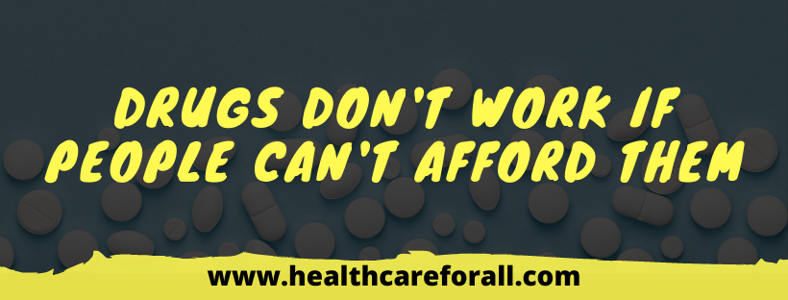

Facebook Post

Everyone deserves access to the care they need, and when the cost of prescription drugs skyrockets while corporations are making record profits, something needs to change. We’ve joined over 250 organizations who are fighting for a healthier Maryland, because drugs don’t work if people can’t afford them. Read more about the affordability crisis gripping our healthcare system and how you can support the fight for change: http://healthcareforall.com/rxresolution

Graphics

