Health Coverage Open Enrollment EXTENSION Toolkit

Newsletter or Email Blurb
Great news! Open enrollment has been extended. Uninsured Marylanders have until February 28 to sign up for health coverage through Maryland Health Connection! Nine out of 10 Marylanders who enroll get financial help to pay for their plan. Plus, Marylanders ages 18-34 have access to additional discounts thanks to a new state law. All plans available through Maryland Health Connection cover important health benefits, including doctor visits, prescriptions, mental health services, and more. Free help is available to choose a plan. Enroll at marylandhealthconnection.gov or call toll-free at 1-855-642-8572.

Printable Flyers

Download PDF of Printable Flyer in English

Download PDF Printable Flyer in Spanish

Social Media and Graphics
For social media graphics and posts in English and Spanish go to: https://thesocialpresskit.com/marylandconnect

Sample:
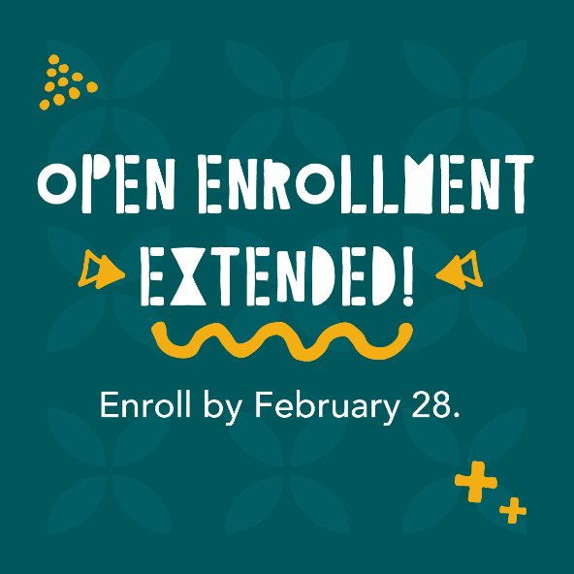

Feb. 28 is your last chance to enroll in a 2022 health plan through @MarylandConnect. Sign up now and see how you can save more than ever before! Go to MarylandHealthConnection.gov.
COVID and Deadline Key Messages (based on messaging from Maryland Health Connection here)

Talking Points
- First and foremost, we encourage all Marylanders to get their COVID vaccine, including their booster if they are eligible. All COVID vaccines are free. As the state and country navigate the increase in COVID infections, we urge everyone living without health insurance to explore their options through Maryland Health Connection today.
  - Find a free vaccine near you at https://coronavirus.maryland.gov/pages/vaccine
- The good news is that the open enrollment period has been extended for when Marylanders can enroll in a 2022 health plan and get savings through Maryland Health Connection. But the deadline is approaching quickly. You must enroll by February 28, 2022 to have health insurance coverage in 2022. But don’t wait that long. If you miss this deadline, you may have to wait until next winter to apply.
- Health insurance can give you peace of mind that no matter what happens – whether it’s a COVID infection or a broken arm – you’re covered and can see a doctor, go to a hospital, and get your prescriptions.
- The best thing you can do today to protect your health is get vaccinated. But because COVID is unpredictable, the next best thing you can do is get a health plan so you can be prepared for whatever happens.
- With a health plan through Maryland Health Connection, you’ll have one less thing to worry about if you need to see a doctor, go to a hospital, or get prescription medicines. Give yourself the peace of mind that comes with having health insurance. Now is not the time to leave your health to chance.

Social Media Message Options
- Priority 1: Get your #COVID vaccine, Maryland. Priority 2: #GetCoveredMD ASAP! The deadline to enroll in a health plan through @MarylandConnect is this February 28, 2022. Enroll in a health plan today so you’re prepared for the unexpected tomorrow.
- COVID may be unpredictable. But you can at least be prepared for medical needs with a health plan through @MarylandConnect. All plans cover doctor visits, mental health services, hospital care, and more. Enroll by February 28 for 2022 health plans. #GetCoveredMD
Additional Maryland Health Connection and deadline social media messages and graphics available here: www.thesocialpresskit.com/MarylandConnect

Email Blurb Options
COVID may be unpredictable. But you can get some peace of mind that you’ll be able to take care of your health if you have a health plan. Maryland Health Connection is the state’s official health insurance marketplace and the only place to get savings on health plans. And this year, there are new, bigger savings available. All plans cover the essentials, including doctor visits, mental health services, prescriptions and more. So, if you want to be sure you’re covered…for whatever happens…now is the time to sign up. The deadline to enroll is February 28, 2022. Go to www.MarylandHealthConnection.gov today, and breather easier tomorrow.

With a new health insurance plan, you’ll be ready for whatever happens. Whether it’s a COVID infection or a broken arm, you can’t always plan for the unexpected. But you can plan for your health. Maryland Health Connection is the state’s official health insurance marketplace and the only place to get savings on health plans. And this year, there are new, bigger savings available. All plans cover the essentials, including doctor visits, mental health services, prescriptions and more. The deadline to enroll is this February 28, 2022. Go to www.MarylandHealthConnection.gov today, and breather easier tomorrow.

Faith Communications
Share these messages with faith leaders and encourage them to use or adapt this language in services, in church bulletins or other newsletters, on social media, and other platforms.
- Your spiritual health is important. Your physical health is too. Having health insurance is an important part of your physical and mental health. When you’re covered, you have the peace of mind you need to take care of your body and your family.
- Kick off the New Year by taking care of your body and soul. And this year, you have until this February 28, 2022 to get a health plan that gives you peace of mind, and access to important services.
- It is always wise to make plans for the future. Health insurance will ensure that you are ready for what life may throw at you. Take care of your health, and your loved one’s, and get covered in 2022.

Creative Communications
- Encourage community leaders to film short videos on their cell phone and post to their personal or organizational social media channels. Encourage them to adapt the talking points to their voice.

About Maryland Health Connection
- Maryland Health Connection is the state’s official health insurance marketplace. It’s your one-stop shop to browse and compare health plans, find savings, and get covered.
- Open enrollment to sign up for a health plan runs until February 28, 2022. Go to MarylandHealthConnection.gov to enroll.
  - You can apply for Medicaid any time of the year.
- All plans available through Maryland Health Connection cover important health benefits, including doctor visits, prescriptions, mental health services, and more.
- Maryland Health Connection offers health plans from insurance companies you know, like CareFirst, Kaiser Permanente, and UnitedHealthcare. This year, no matter where you live in Maryland, you will have a choice of plans from multiple insurance companies.
About New Savings
- You can get free or low-cost health insurance through Maryland Health Connection. In fact, 9 out of 10 Marylanders who enroll get financial help to pay for their plan.
- This year, there are more savings available than ever before. Many people can even get a health plan for as little as $1 a month depending on income level and household size. Even if you’ve looked before, it’s worth coming back, because there are now savings available for households at all income levels.
- Thanks to a new law, Marylanders with higher incomes can now get financial help to cover some of their health plan costs. Even if you have shopped before, it’s worth coming back to check out your options.
- There are new discounts for Marylanders ages 18-34 — on top of other savings available through Maryland Health Connection.

About Enrollment Assistance
- If you need help enrolling, we’ve got you covered. Trained experts are available to help you sign up for a health plan from the comfort of your own home. Go to MarylandHealthConnection.gov/ help to find help near you.
Our call center offers support in more than 200 languages including Relay for the deaf and hard of hearing. Call us toll-free at 1-855-642-8572.

