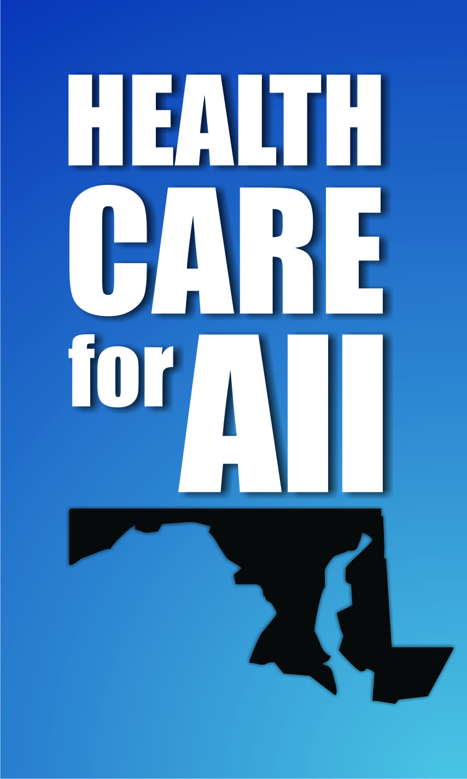
Regional Summits: Outreach for the Second Open Enrollment Period of the Health Benefit Exchange
Last year MCHI coordinated three statewide outreach summits, which brought together over 70 stakeholders from across the state to plan, implement and evaluate a shared outreach plan. Thanks to your positive feedback, this year we decided to help coordinate local summits in partnership with the Maryland Health Benefit Exchange; the regional connector entities; and our local coalition partners, including trusted community leaders from faith groups, businesses, and service providers.

Region | Lower Shore—already has a monthly steering committee meeting | Prince George’s County | Southern Maryland | Upper Shore | Montgomery County | Central Region
Date/Time/Location | 9/10, 10AM-12PM, WCHD office | 9/17, 9-11:15AM, Oxon Hill Manor | 9/25, 9:30-11:30 AM, College of Southern MD | 9/30, 1:00-3:00PM, Elkton Library | 10/1, 10AM-12:00PM, Universalist Unitarian Congregation of Rockville | 10/22, 10AM-12PM, Med Chi, Baltimore
Connector Entity | Worcester County Health Department | Montgomery County DHHS | Calvert Healthcare Solutions | Seedco | Montgomery County DHHS | HealthCare Access Maryland
Attendees | 17  DSS, local health departments, hospital/medical center representation | 100+  DSS, local health department, formal partners, and community organizations | 24  DSS, local health departments, hospital executives, local brokers, chamber of commerce officials, and the local navigator entity staff | 18  DSS, local health departments, hospital and medical center executives, local navigator entity staff, community organizations | 63  DSS, local health department, faith groups, college leaders, formal partners, and other community organizations | 55  DSS, formal partners, brokers, statewide and community organizations
Speakers | Kat Gunby  Randi Clark  Dan Hirko  Stephanie Klapper | Carolyn Quattrocki  County Exec. Baker  Katie Wunderlich  Matt Celentano  Local officials | Mike Shaw  Ginny Seyler  Matt Celentano | Ginny Seyler  Mark Romaninsky  Matt Celentano | Rev. Kaseman  Matt Celantano  Carolyn Quattrocki  Uma Ahulwalia  Rev. Louise Malbon-Reddix  Leni Preston | Kathleen Westcoat  Matt Celentano  Carolyn Quattrocki  Formal Partners  Kris Rusch  Ilma Imamovic
Format | Informal presentations and roundtable discussion | Presentations followed by networking | Presentations, Q&A, and roundtable discussion | Presentations, Q&A, and roundtable discussion | Presentations, Q&A, networking | Presentations, Q&A

