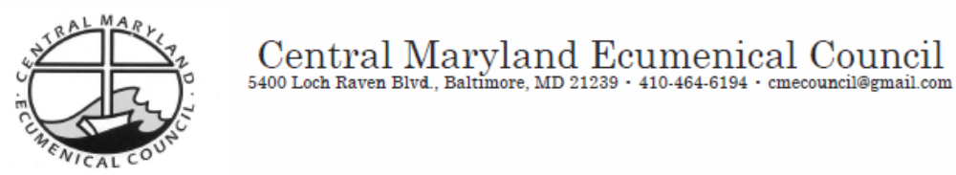

April 30, 2012

Hon. Martin O’Malley
Governor of the State of Maryland
100 State Circle
Annapolis, Maryland 21401

Hon. Michael Busch
Maryland House Speaker
State House, H-101
Annapolis, MD 21401

Hon. Thomas V. Mike Miller
Maryland Senate President
State House, H-107
Annapolis, MD 21401

Dear Governor O’Malley, Speaker Busch and President Miller:

As Dr. Martin Luther King, Jr. said, “The time is always right to do what is right.” And the time is both right and ripe for a Special Session to be held without delay.

We are members and leaders of Maryland’s faith community. We join together to urge a quickly convened Special Session to undo the “Doomsday Budget” because we are all too acquainted with the pressing, sometimes desperate needs of our congregants and the communities in which we serve. Revisiting and correcting what was left undone on April 9 is an imperative moral issue.

The Doomsday Budget would strip more than $128 million from K-12 Education funding, and impose cuts to higher education. That translates into greater class sizes, fewer programs, and higher tuitions. More than 500 state jobs are in jeopardy, and $150 million in cuts to state agencies are planned. These are larger cuts than the General Assembly’s budget committees were able to identify in ten weeks of detailed analysis and hearings. Public safety, health, and general welfare are all touched. Even before these additional losses, the ranks of our state employees are so thin that in recent years we have not had sufficient state personnel to process emergency cash assistance requests, leading to a lawsuit against the state, and we have seen caseloads balloon to unmanageable proportions in such critical areas as probation and parole, mental health facilities and emergency services. In Maryland, the country’s wealthiest state, this is intolerable.

Additionally, because the revenue package and the Budget Reconciliation and Financing Act (BRFA) did not pass in the waning hours of session, a number of very important measures, such as the increased tax for smokeless (chew and spit) tobacco and little cigars, fell as well. This failure compromises our children's well-being and very lives. The evidence is clear: raising cigarette taxes over the past 10 years has discouraged youth smoking of cigarettes, and saved about 70,000 lives. At the same time youth use of little cigars and smokeless tobacco has gone up. By raising the tax on little cigars to 70%, and on smokeless tobacco to 30%, we can save thousands of young Marylanders from addiction to these deadly products.

We understand and believe that the Doomsday budget’s harsh results were not intended, and that Senate and House conferees agreed to a budget agreement with sufficient revenue to avoid these cuts before Sine Die. Although we cannot turn back the clock, we can ask that such an agreement be enacted as soon as possible. There is no time to waste. We must do right for the least among us, and for all our fellow citizens.

We thank you for all the good you have done for Maryland, in this session and in sessions past. We ask you to avert “Doomsday,” a condition that we never would wish to bring upon our state.

Very Sincerely,

Leaders of Denominations and Major Faith Groups
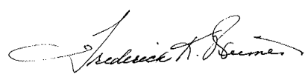
Rev. Fred Weimert, President, Central Maryland Ecumenical Council
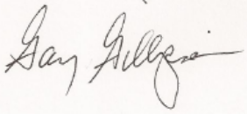
Gary Gillespie, Executive Director, Central Maryland Ecumenical Council
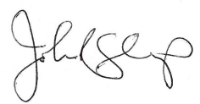
Rev. Jack Sharp, President Emeritus, Central Maryland Ecumenical Council
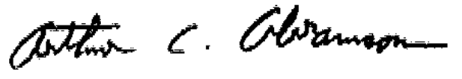
Arthur C. Abramson, Ph.D., Executive Director, Baltimore Jewish Council
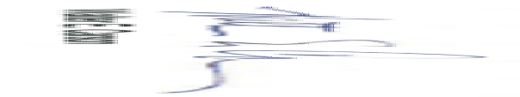
Walter E. Carson, Esq., Vice President and General Counsel, Columbia Union Conference of Seventh-day Adventists

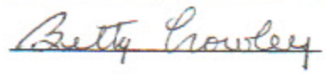
Betty Crowley, Unitarian Universalist Legislative Ministry of Maryland
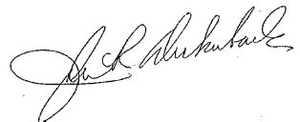
Rev. Dr. John Deckenback, Conference Minister, Central Atlantic Conference, United Church of Christ
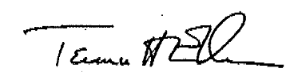
Rev. Dr. Terence H. Ellen, Executive Director, Unitarian Universalists for Social Justice in the National Capital Region

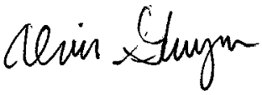
Rev. Alvin Gwynn, President, Interdenominational Ministerial Alliance
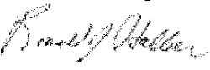
Mr. Ron Halber, Executive Director of the Jewish Community Relations Council
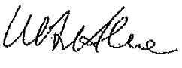
Bishop Wolfgang Herz-Lane, Delaware Maryland Synod, Evangelical Lutheran Church in America (ELCA)
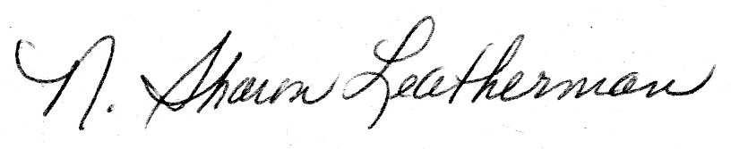
N. Sharon Leatherman, President, Church Women United in Maryland
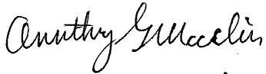
Rev. Anthony Maclin, President, Collective Empowerment Group
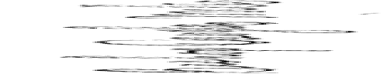
Bishop Douglas Miles, Co-Chair, Baltimoreans United In Leadership Development (B.U.I.L.D.)
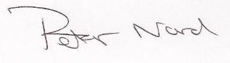
Rev. Dr. Peter Nord, General Presbyter, The Presbytery of Baltimore
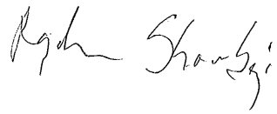
Raghid Shourbaji, President, Howard County Muslim Council
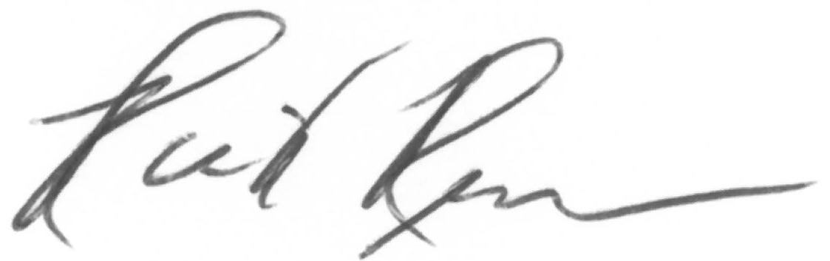
Rick Remmers, DMin, President , Chesapeake Conference of Seventh-day Adventists
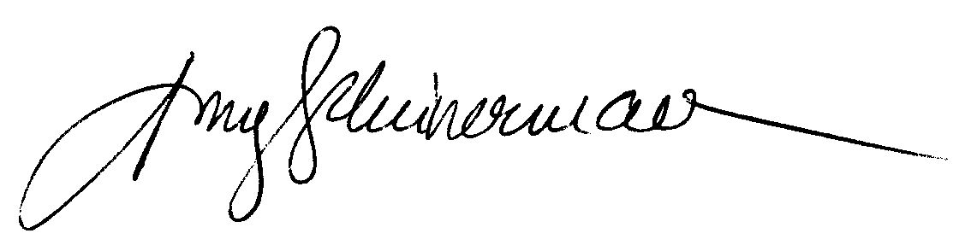
Rabbi Amy Scheinerman, President, Baltimore Board of Rabbis
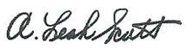
A. Leah Scott, Health Ministries Director, Allegany East Conference, Seventh-day Adventists
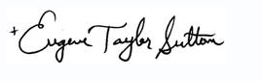
The Rt. Rev. Eugene Taylor Sutton, Episcopal Bishop of Maryland

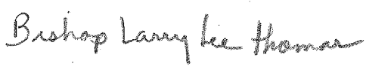
Bishop Larry Lee Thomas, United Christian Clergy Alliance of Anne Arundel County

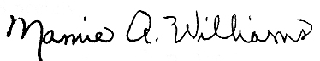
Rev. Mamie Williams, President R.E.S.P.E.C.T

Clergy and Lay Community Leaders

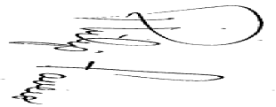
Philip Favero, Peace and Justice Center – Annapolis Friends Meeting
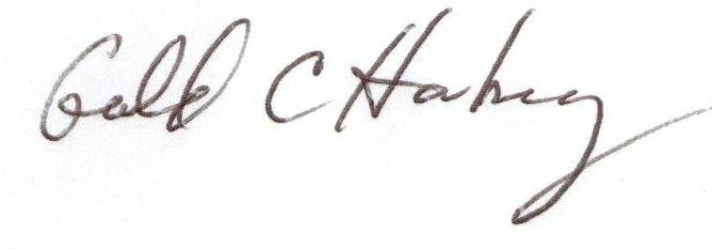
Gerald C. Hanberry, Emanuel United Church of Christ (Carroll County)
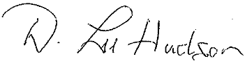
Rev. Lee Hudson, Pastor, Messiah Lutheran Church (Baltimore City)
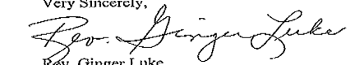
Rev. Ginger Luke, River Road Unitarian Universalist Congregation (Montgomery County)

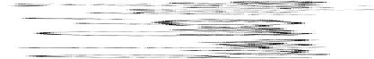
Pastor Dante Miles, Koinonia Baptist Church (Baltimore City)
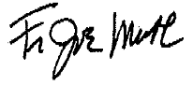
Father Joe Muth, Pastor, St. Matthews Catholic Church (Baltimore City)
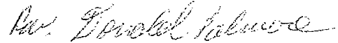
Rev. Donald Palmore, New Samaritan Baptist Church (Baltimore City)
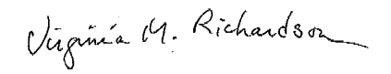
Virginia M. Richardson, River Road Unitarian Universalist Congregation, Social Justice Council
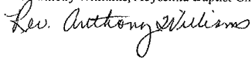
Rev. Anthony Williams, Abyssinia Baptist Church (Baltimore City)

