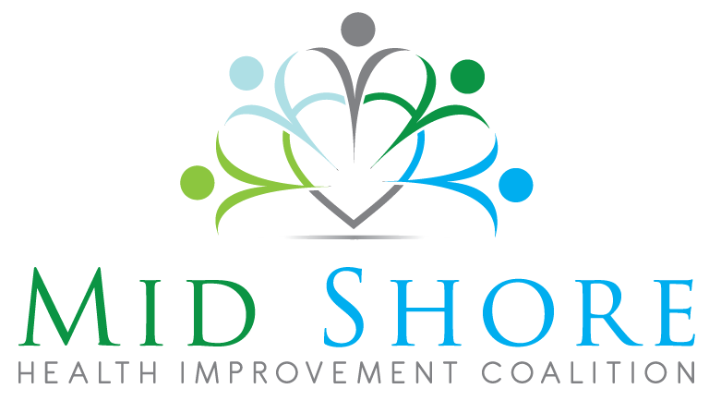
LHIC MEETING AGENDA – MONDAY, MARCH 09, 2015
12:00 - 12:20 Lunch-*shortened to accommodate a full agenda*
12:20 - 12:30 Welcome and Introductions: Dr. Spencer
12:30 - 12:50 Brief Update from Regional Partners:
-Shore Health Systems
-Choptank Community Health Systems
-Eastern Shore Area Health Education
-Mid Shore Mental Health Services
12:50 - 12:55 Regional Community Based Grant Initiative Update: Nicole Morris
12:55 - 1:30 Presentation: Suzanne Schlattman, Maryland Healthcare For All Coalition:
Public Forum: Maryland's New All Payer Payment Model and the Impact on Local Public Health
1:30 - 2:00 Presentation: Erin Hill, Regional Opioid Misuse Prevention Grant Coordinator:
Overview of Regional Opioid Misuse Prevention Program Grant
Local Health Improvement Coalition Meetings are held at Queen Anne’s County Health Department in Centreville, MD on a quarterly basis. A healthy lunch is served from 12:00-12:30 pm, and the meeting takes place from 12:30-2:00 pm.

